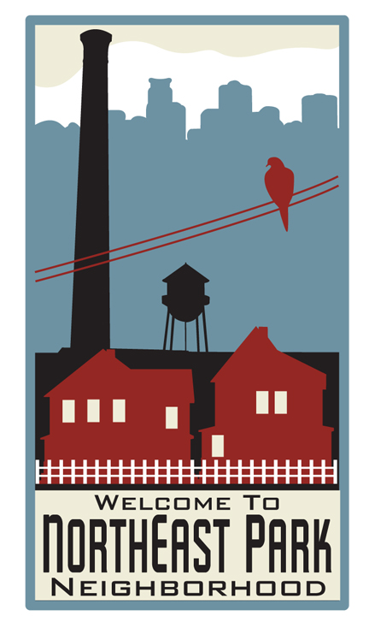
NEIGHBORHOOD AND COMMUNITY ENGAGEMENT
COMMUNITY PARTICIPATION PROGRAM

2017-2019 APPLICATION

Approve by the neighborhood on 12/14/16

COMMUNITY PARTICIPATION PROGRAM
Application Template

Please feel free to use this template as a guide to developing your submission for funding from the Community Participation Program. The level of detail should be appropriate to your organization’s proposed activities, and to the level of funding allocated for your organization.

CONTACT INFORMATION:

Organization Name: | Northeast Park Neighborhood Association (NEPNA)
Address: | P.O. Box 18012  Minneapolis, MN 55418
Website url: | www.northeastpark.org
Organization email: | info@northeastpark.org
Federal EIN:
Board Contact: | Name: Laurie Anderson, Treasurer  Phone:  Email: ljliand@comcast.net  Address:  Minneapolis, MN 55413
Staff Contact: | Name: Christie Rock Hantge  Phone: 320-583-4573  Email: christie@hantge.com  Address: 1210 Lewis Avenue SW, Hutchinson, MN 55350

Who should be the primary contact for this submission? Neighborhood Coordinator Christie Rock- Hantge

Date of Board review and approval: The NEPNA Board voted unanimously to approve this application on Wednesday, December 14, 2016.

The Northeast Park Neighborhood Association Board of Directors very much appreciates the opportunity to apply for the Neighborhood and Community Engagement – Community Participation Program funds.

FUNDING ACTIVITIES
Use the following questions as a guide for your submission. For questions 1-8, please limit each response to no more than 3 paragraphs.
- Eligibility. If your organization has not previously been funded through the Community Participation Program, please provide evidence of the organization's eligibility, as identified in Section II of the Guidelines.
Northeast Park Neighborhood Association received funding through the 2011, 2012-2013 and 2014-2016 Community Participation Program funding cycles.
- Community participation efforts. Describe proposed outreach activity in the neighborhood, and methods to involve residents and other stakeholders in one or more of the three key program purposes. How will you engage residents and other stakeholders of their neighborhood in developing a Neighborhood Priority Plan?
NEPNA intends to engage neighborhood residents through a variety of means during the next funding cycle (2017-2019), including the following:
NEPNA is in the process of hiring a community organizer who will help the board develop an outreach and engagement plan. The plan will include, but not be limited to the following strategies:
  - Use the organization’s Web site, email list and Facebook page to invite community members to board meetings and other community events.
  - Door-knock the neighborhood to try and attract new members and volunteers, to increase participation of non-board members at board meetings, and to gain input on strategies and initiatives to include in the Neighborhood Priority Plan.
  - Develop a survey instrument using Survey Monkey to gain input on strategies and initiatives to include in the Neighborhood Priority Plan.
  - Hold a minimum of two focus group sessions to gain input on strategies and initiatives to include in the Neighborhood Priority Plan.
  - Organize a neighborhood-wide National Night Out celebration.
- Building organizational capacity. How will you work to: (1) provide opportunities for the direct involvement of members, (2) build your membership and volunteer base, (3) encourage and develop new leadership, and (4) expand the organization's capacity through self-assessment and other activities?
NEPNA is in the process of hiring a community organizer who will help the board develop an outreach and engagement plan to build organizational capacity. In addition, NEPNA does the following:

  - NEPNA holds regular monthly board meetings on the second Wednesday of every month where neighborhood residents offer input to current issues. Community members are invited to attend via the organization’s new Web site, www.northeastpark.org, the organization’s Facebook page, and through the organizations’ email list.
  - NEPNA also promotes board meetings in the local newspapers.
  - On an as-needed basis, NEPNA mails a meeting announcement/ informational newsletter to every residence in Northeast Park.
  - NEPNA volunteers will also door-knock the neighborhood to help gain membership and attract new volunteers.
  - NEPNA will seek ways to collaborate in new and creative ways with other organizations based in Northeast Minneapolis that are working to make the neighborhood a better place to live, work and play.
  - NEPNA will host one annual meeting per year. NEPNA promotes the annual meeting via the Downtown Journal, the Northeaster, the organization’s Web site, and the Facebook page.
  - The board will dedicate one meeting per year for self-assessment and priority planning and/or training with an outside facilitator, possibly the neighborhood’s NCR Specialist.
- Building neighborhood relationships. Describe your outreach, networking and inclusivity efforts to: (1) build a sense of a whole neighborhood among residents, (2) build bridges among neighbors and diverse communities within the neighborhood, (3) work with other neighborhoods and organizations on issues of common interest, (4) build partnerships with private and public entities, and (5) benefit the neighborhood as a whole.
NEPNA is in the process of hiring a community organizer who will help NEPNA build relationships within the neighborhood itself, and with other neighborhood organizations in Northeast Minneapolis. The community organizer will participate in the monthly NE Staff meeting.
NEPNA currently engages community members through a variety of methods, including the following:
  - NEPNA Web site, www.northeastpark.org
  - NEPNA Facebook page

Nextdoor

Downtown Journal

  - Northeaster
  - Surveys
  - Emails from the Chair
  - Monthly board meetings
  - Community events, i.e.
  - Mailers from Center for Energy and Environment for Home Improvement Programs
- Work with City departments and other jurisdictions. Discuss your efforts to connect with City of Minneapolis departments and other jurisdictions on behalf of your community and in support of your neighborhood priorities. Please also discuss how the NCR Department can help with this work.
NEPNA regularly communications with its NCR Specialist Jack Whitehurst. NEPNA’s Neighborhood Coordinator also routinely corresponds with CPED Finance staff Bob Cooper and Judy Duffey. All of these people are easy to work with and very responsive.
- Involvement of under-engaged stakeholders. Discuss which stakeholder groups are typically un-engaged or under-engaged in your work, and how you will work to involve those groups. Please also discuss how the NCR Department can help with this work.
Renters are the most prominent group that is under-engaged or under-represented at NEPNA meetings and events. NEPNA will make an effort to find out who the rental property owners and landlords are, and work with them to help spread the word about neighborhood meetings, activities and events to tenants.
Businesses in retail and wholesale have also typically been under represented at NEPNA meetings and events. NEPNA can door knock neighborhood businesses to create awareness of the neighborhood organization, as well as notify them about community events and activities.
NEPNA is in the process of hiring a community organizer who will help NEPNA build relationships within the neighborhood.
- Unused funds. Discuss how you plan to use unused funds from the previous cycle for community engagement or implementation of neighborhood priorities.
NEPNA intends to use unspent funds from its 2014-2016 allocation to continue to implement outreach and engagement activities outlined in the 2017-2019 CPP application.
In addition, NEPNA plans to develop a survey instrument using “Survey Monkey” to gain suggestions from the community in order to prepare their Neighborhood Priority Plan.
- Housing Activities. Neighborhood organizations should discuss their work on housing and housing related activities. Organizations should estimate the percentage of time to be spent on these issues.
NEPNA will continue to offer matching grants to single family, owner-occupied housing units and duplexes via its NRP program.
NEPNA regularly communicates with the loan program administrator Greater Minneapolis Housing Corporation to ensure that the program is meeting the current marketplace needs.
NEPNA estimates that it will spend 25 percent of its time working on housing related activities.
- Budgets. Submissions should include a budget showing how Community Participation Program funds will support the organization’s community participation work and an amount set-aside for implementation of Neighborhood Priority Plans. An annual budget for the organization should also be provided.

Please see the attached three-year budget.

Thank you very much for your consideration of this plan.

________________________________________________
Laurie Anderson, Treasurer
Northeast Park Neighborhood Association

